**National University of Computer & Emerging Sciences**

**Karachi Campus**



**Project Report**

**AI-2002**

**Artificial Intelligence**

**Posture Corrector + Rep Counter**

***A Pose Estimation Model***

**Ali Iqbal 20K-0141**

**Mujtaba Ahmed 20K-1801**

**Ahmed Azaan 20K-1099**

**Bs (AI)-4A**

___________________________________________________________________________________

1. **Acknowledgment**

We came up with this idea with the help of our course teacher Dr Farukh Shahid and some web search. Stack overflow website had many different ideas related to the project that we could work on and basically provided us with some core posture corrector ideas that we could modify and then implement so we as a group decided to go for it since it was quite comprehensive. Apart from efforts of all the team members, the section of this project report topic depends largely on the encouragement and guidance provided by our teachers. We take this opportunity to express our gratitude to the teachers who have been instrumental in the approval of this topic.

1. **Introduction**

Human pose estimation from video plays a critical role in various applications such as [quantifying physical exercises](https://google.github.io/mediapipe/solutions/pose_classification.html), sign language recognition, and full-body gesture control. For example, it can form the basis for yoga, dance, and fitness applications. It can also enable the overlay of digital content and information on top of the physical world in augmented reality.

Media Pipe Pose is a ML solution for high-fidelity body pose tracking, inferring 32 3D landmarks and background segmentation mask on the whole body from RGB video frames utilizing our [Blaze Pose](https://ai.googleblog.com/2020/08/on-device-real-time-body-pose-tracking.html) research that also powers the [Pose Detection API](https://developers.google.com/ml-kit/vision/pose-detection).

The detector is inspired by our own lightweight Blaze Face model, used in [Media Pipe Face Detection](https://google.github.io/mediapipe/solutions/face_detection.html), as a proxy for a person detector. It explicitly predicts two additional virtual key points that firmly describe the human body center, rotation and scale as a circle

A visual representation of the 3D landmarks of the whole body is shown below:

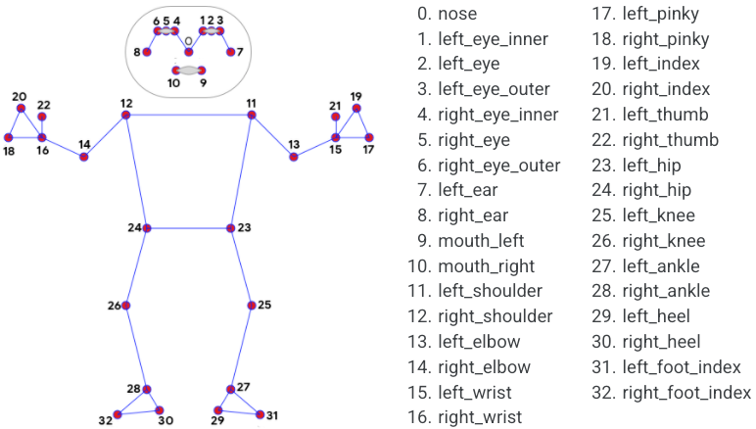

1. **Tools and technologies used**

Programming language: **Python**

Operating System: **Windows**

Tool used: **Jupyter Notebook**

List of header files:

* **Media Pipe**
* **Opencv**

1. **Project Overview & Objectives:**

The Project will basically emphasize on a category of pose estimation model that is to replicate the function of 2 different gym exercises namely bicep curls and pushups.

2 Objectives:

* Posture correction(angle wise)
* Rep count after each successful Rep.

1. **Project Details:**

The Project will implement the above objectives. Basically this project will emphasize on the Bicep Curl **&** Pushups exercise. First of all the program will ask the user to select the type of exercise they are willing to do. Model will be trained accordingly for the particular exercise.

As mentioned above, with the help of python libraries including tensor flow & Media pipe we will be providing model with the coordinates across the human body from shoulder bone to the wrist of the person.

Furthermore if the concerned user has performed a rep properly and the angle is correct, automatically the count of the respective exercise will be incremented by 1 each time allowing the user to continue with the reps.

The Pose detector is inspired by our own lightweight [Blaze Face](https://arxiv.org/abs/1907.05047) model, used in Media Pipe, as a proxy for a person detector. It explicitly predicts two additional virtual key points that firmly describe the human body center, rotation and scale as a circle. Inspired by [Leonardo’s Vitruvian man](https://en.wikipedia.org/wiki/Vitruvian_Man)(also shown in diagram below), we predict the midpoint of a person’s hips, the radius of a circle circumscribing the whole person, and the incline angle of the line connecting the shoulder and hip midpoints.

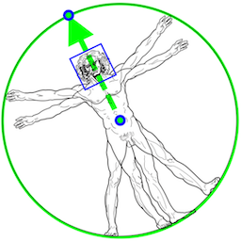

 Model will try to detect the most prominent person in the very first images, and upon a successful detection further localizes the pose landmarks. In subsequent images, it then simply tracks those landmarks without invoking another detection until it loses track, on reducing computation and latency.

**5. Project Features:**

* Right Arm Bicep Curl
* Left Arm Bicep Curl
* Pushups
* Shoulder Press

**6. Link to source**

* <https://google.github.io/mediapipe/solutions/pose.html>
* https://github.com/nicknochnack/MediaPipePoseEstimation

**7. Result:**

**Project Demonstration Link**

**https://youtu.be/iGXiK932rbw**

**Bicep Counter**

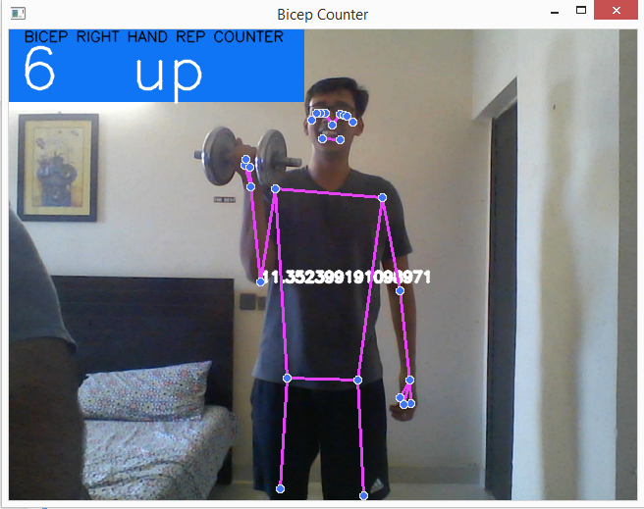

**Pushup Counter**

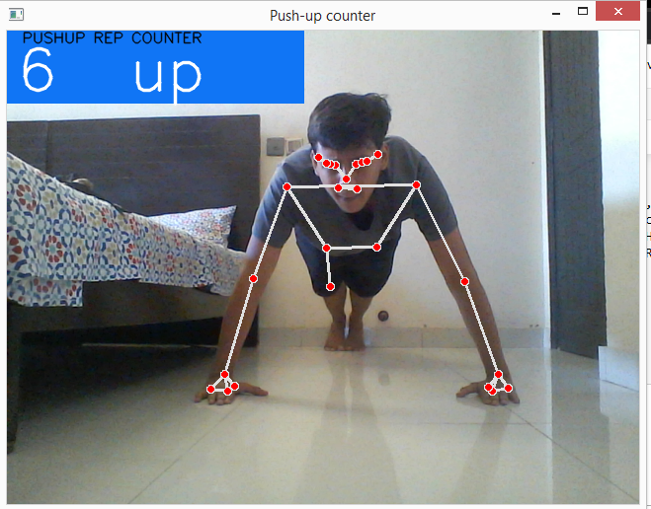

**Shoulder Press Counter**

